# Document History

The master version of this document is stored by TfL in the FTP TFS Source Control at; $/Deployment/Main/Documents.

Any version of this document not from this location is not controlled.

|  |  |  |  |
| --- | --- | --- | --- |
| **Date** | **Version** | **Changes** | **Changed By** |
| 10/07/2014 | 1 | Released | Nitin Chadha |
|  |  |  |  |

AppFabric Installation Guide FAE for Staging environment expansion

Prerequisites

* Windows Server 2008 Enterprise or DataCenter Editions (Full GUI).Requires .NET 4.0
* AppFabric 1.1
* Service Accounts
  + FAE Service account –zsvcfae (Need Run as service, run batch jobs, local admin)
  + SSO Service account –zsvcappfab (Need Run as service, run batch jobs, local admin)
* The AppFabric Cluster and the server running the client application (e.g. pipelinehost.exe) has to be on the same domain.
* For non scale environments we are using the **file system** to store the configuration files.

## Install the AppFabric caching software on the Hosts

### Install AppFabric Caching Software

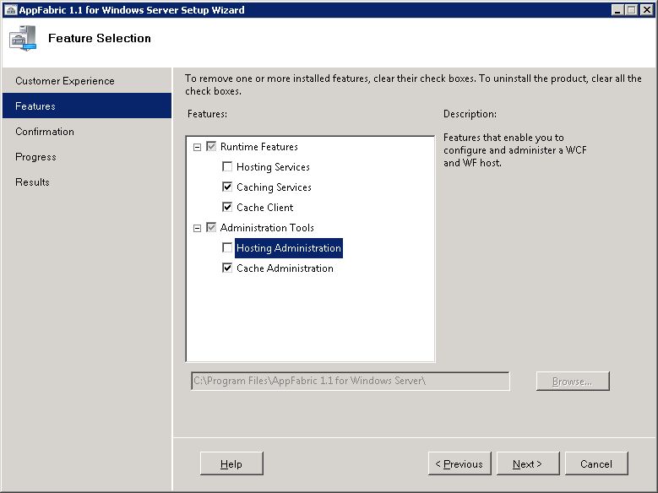

(Fig 1)

### Install cumulative rollup: <http://support.microsoft.com/kb/2716015/EN-US>O

## Setup AppFabric server configuration

Create a folder share on the same machine and call it **AFConfigSettingsDoNotDelete**

Copy the UNC path of the folder e.g. **\\machinename\D$\AFConfigSettingsDoNotDelete** and paste to the file share as shown below.

Select New Cluster and click next and then click finish.

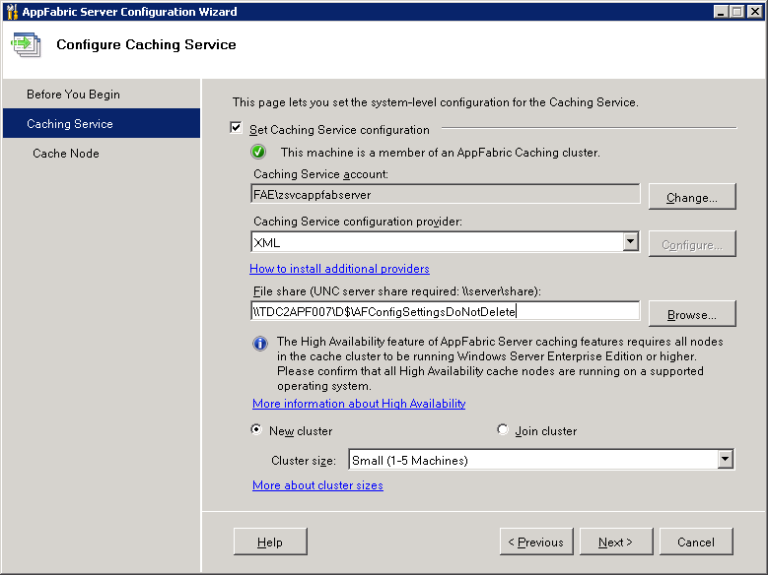

(Fig 2b)

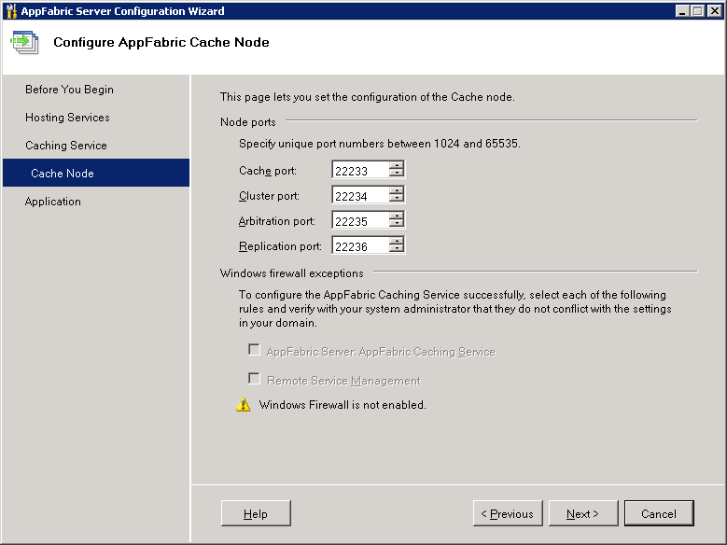

(Fig4)

## AF Cluster Administration - for FAE instance of AppFabric

### On any AppFabric Cache host - Open “Caching Administration Windows PowerShell” in Start -> "All Programs" -> "AppFabric for Windows Server Setup AppFabric server configuration

(In the hardened environments - Right click and open using "Run as administrator")

### Enter Start-CacheCluster

### On the FAE instance of the AppFabric server create new cache by using New-Cache FAEIntraday

### Grant <Internal domain>\zsvcfae the AF cache access. Grant-CacheAllowedClientAccount < domain>\zsvcfae

## AF Cluster Administration - for SSO instance of AppFabric

### On any AppFabric Cache host - Open “Caching Administration Windows PowerShell” in Start -> "All Programs" -> "AppFabric for Windows Server Setup AppFabric server configuration

(In the hardened environments - Right click and open using "Run as administrator")

### Enter Start-CacheCluster

### On the SSO instance of the AppFabric server create new cache by using New-Cache SSO

### Grant <Internal domain>\zsvcfae the AF cache access. Grant-CacheAllowedClientAccount < domain>\zsvcappfab

## Setup APF Cache powershell monitoring scripts

### Open windows explorer Go to %System32\WindowsPowerShell\v1.0 and create a new folder. Name it "Custom".

### Copy StartApfabricHostOnServerBoot.ps1 to the folder created above.

### Open windows task scheduler. Import the task Appfabric Host Start.xml

Before clicking ok after each import, change the user to   
**domain**\zsvcfae for FAE instance

**domain**\zsvcappfab for SSO instance

### In the task scheduler library, make sure the newly imported tasks are listed.

Basic tasks and Support

* To check if the cachecluster is up and running.  
    
  Run Get-CacheHost
* To Stop/Start the AppFabric Caching - Open powershell for AppFabric  
    
  Run Stop-CacheCluster or Start-CacheCluster

(Stop the Caching using the command above if you are permanently disabling the AppFabric caching)

* To check for number of items stored in the AppFabric Cache  
    
  Run Get-CacheStatistics SSO  
    
  or Get-CacheStatistics FAEIntradayHA

* If you are installing AppFabric for the first time, make sure to install cumulative rollup afterwards: <http://support.microsoft.com/kb/2716015/EN-US>
* The service account which is being used to run the service must be setup on the DB with Read/Write and Execute on the same.
* Note: **DO NOT** Stop/Start the AppFabric caching host service from the Service Control Manager.